**Intelligent Customer Retention: Using Machine Learning for**

**Enhanced Prediction of Telecom Customer Churn**

**OVERVIEW:**

An intelligent system for handling the customer retention task, which is getting important due to keen competition among companies in many modern industries. Taking wireless telecommunication industry as a target of research, our system first learns an optimized churn predictive model from a historical services database by the decision tree-based technique to support the prediction of defection probability of customers

**Technical Architecture :**

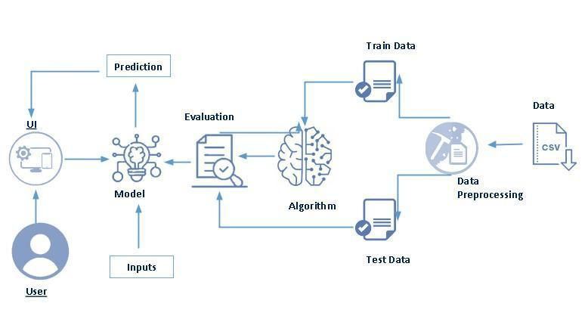

**Technical About the project:**

Machine learning is merely based on predictions made based on experience. It enables machines to make data driven decisions ,which is more efficient than explicitly programming to carryout certain tasks. These algorithm are designed in a fashion that gives exposure to new data that can help organizations learn and improve their strategies.

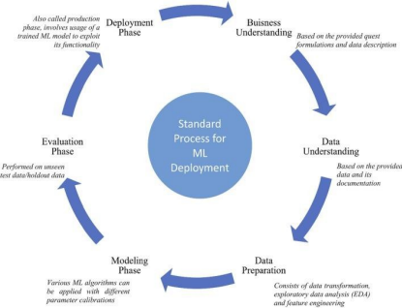

**A Project Description:**

Customer churn is often referred to as customer attrition, or customer defection which is the rate at which the customers are lost. Customer churn is a major problem and one of the most important concerns for large companies. Due to the direct effect on the revenues of the companies, especially in the telecom field, companies are seeking to develop means to predict potential customer to churn. Looking at churn, different reasons trigger customers to terminate their contracts, for example better price offers, more interesting packages, bad service experiences or change of customers’ personal situations

Customer churn has become highly important for companies because of increasing competition among companies, increased importance of marketing strategies and conscious behaviour of customers in the recent years. Customers can easily trend toward alternative services. Companies must develop various strategies to prevent these possible trends, depending on the services they provide. During the estimation of possible churns, data from the previous churns might be used. An efficient churn predictive model benefits companies in many ways. Early identification of customers likely to leave may help to build cost effective ways in marketing strategies. Customer retention campaigns might be limited to selected customers but it should cover most of the customer. Incorrect predictions could result in a company losing profits because of the discounts offered to continuous subscribers.

Telecom companies often use customer churn as a key business metrics to predict the number of customers that will leave a telecom service provider. A machine learning model can be used to identity the probable churn customers and then makes necessary business decisions.

Telecommunication industry always suffers from a very high churn rates when one industry offers a better plan than the previous there is a high possibility of the customer churning from the present due to a better plan in such a scenario it is very difficult to avoid losses but through prediction we can keep it to a minimal level

**Project Flow:**

● User interacts with the UI to enter the input.

● Entered input is analysed by the model which is integrated.

● Once model analyses the input the prediction is showcased on the UITo accomplish this, we have to complete all the activities listed below.

**● Define Problem / Problem Understanding:**

○ Specify the business problem

○ Business requirements ○ Literature Survey

○ Social or Business Impact**.**

**● Data Collection & Preparation:**

○ Collect the dataset

○ Data preparation

**● Exploratory Data Analysis :**

○ Descriptive statistical

○ Visual Analysis

**● Model Building:**

○ Training the model in multiple algorithms

○ Testing the model

**● Performance Testing & Hyperparameter Tuning :**

○ Testing model with multiple evaluation metrics

○ Comparing model accuracy before & after applying hyperparameter tuning

● **Model Deployment:**

○ Save the best model

○ Integrate with Web Framework

**● Project Demonstration & Documentation:**

○ Record explanation Video for project end to end solution

○ Project Documentation-Step by step project development procedure

**Project Structure:**

Create a Project folder which contains files as shown below

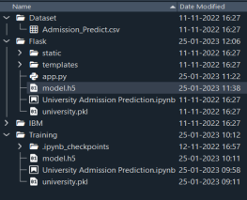

● A python file called app.py for server side scipting.

● We need the model which is saved and the saved model in this content is churn.pkl

● Templates folder which contains base.HTML file, index.HTML file, predyes.HTML , predno.HTML file.

● Static folder which contains css folder which contains main.css , js folder which contains global.js , images folder

**Purpose:**

Machine Learning has an additional benefit of processing large chunks of data that is sometimes tiresome for men to do and eventually lead to a failure in making the right decision. It is easily adaptable to new and complex data. After processing the data, it is capable of analyzing any flaws or errors. These also help in creating effective plans of Actions for improvement. There is a co- relation between inputs and outputs in the process of decision-making. These points are extremely useful for ventures that work mainly around risk management.

**PROBLEM DEFINITION AND DESIGN THINKING :**

Machine learning has become an increasingly popular tool in recent years, givenits ability to automatically detect patterns in data and make predictions about future events. This can be extremely useful for making decisions in a wide range of domains, from financial trading to medical diagnoses

**EMPHATHY MAP:**

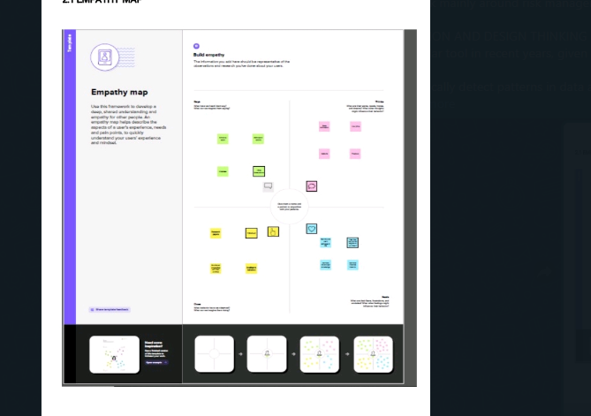

**Ideation and Brainstorming Map:**

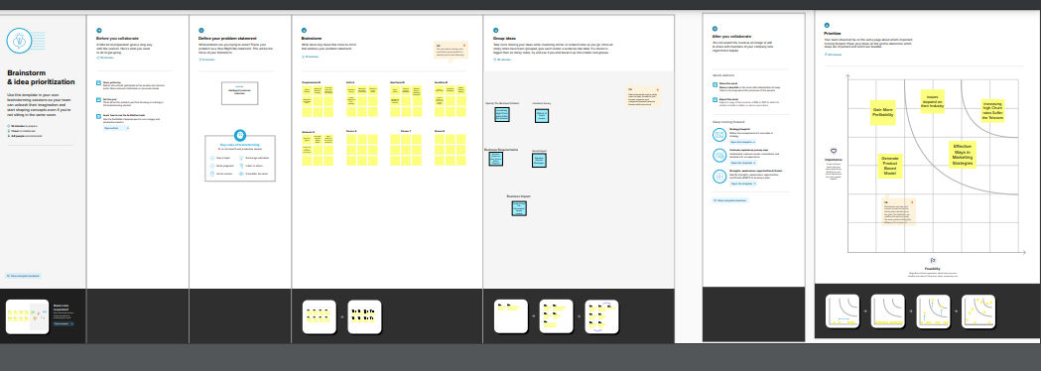

**SOURCE CODE:**

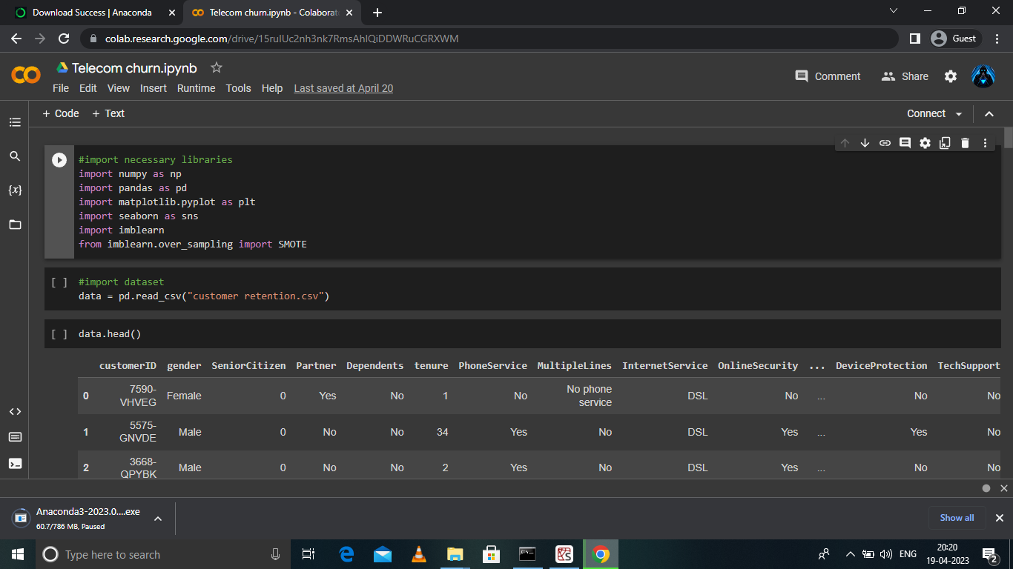

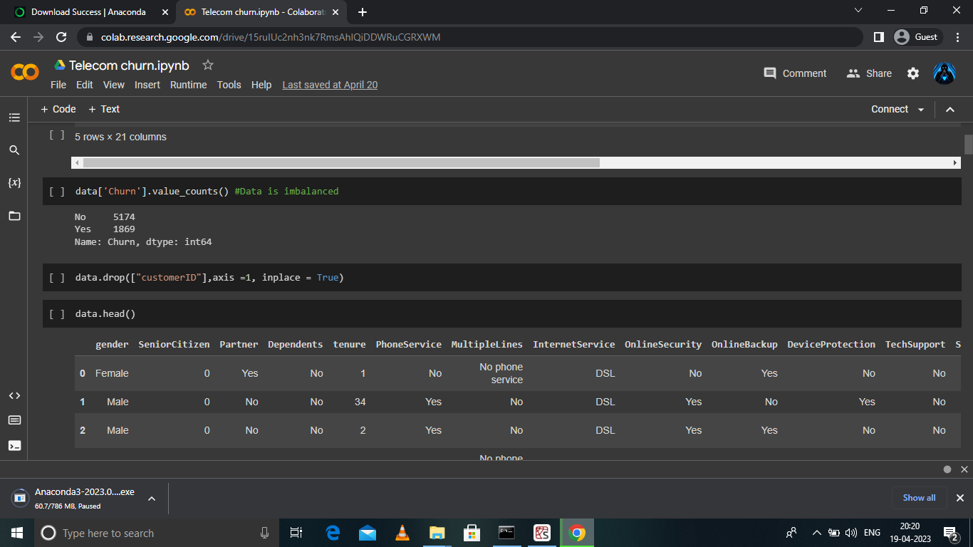

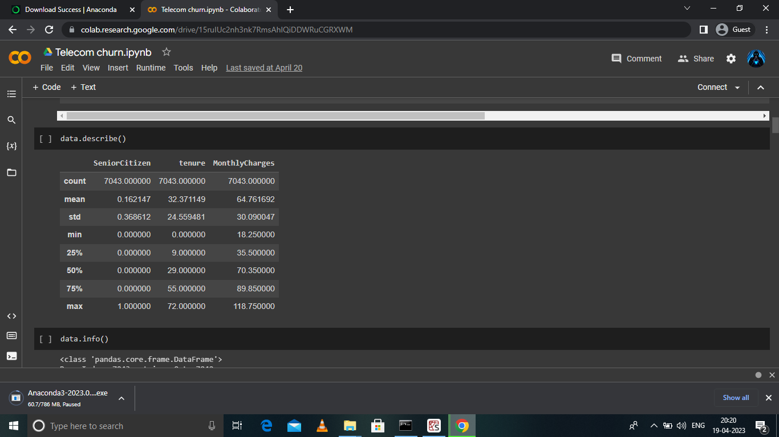

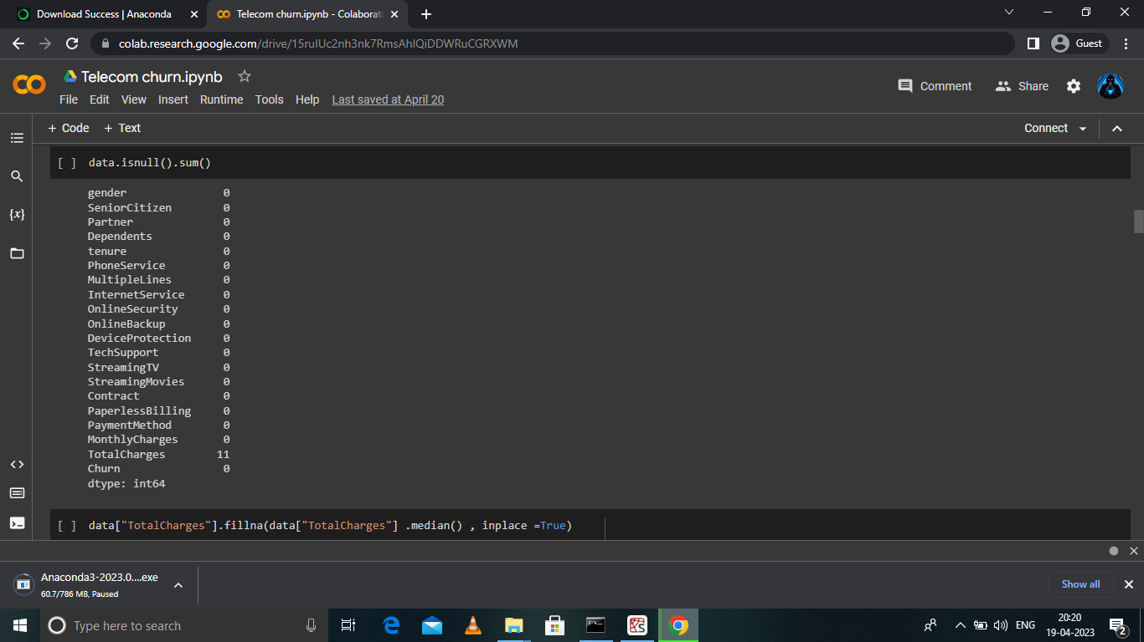

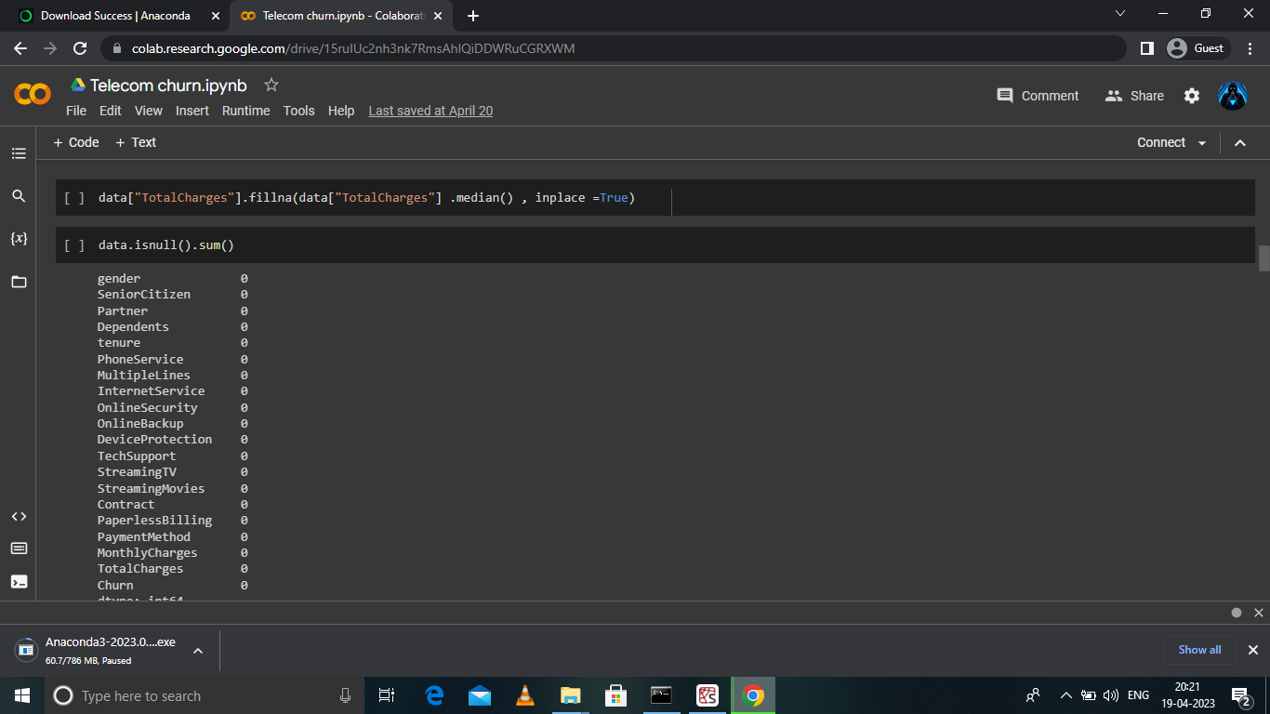

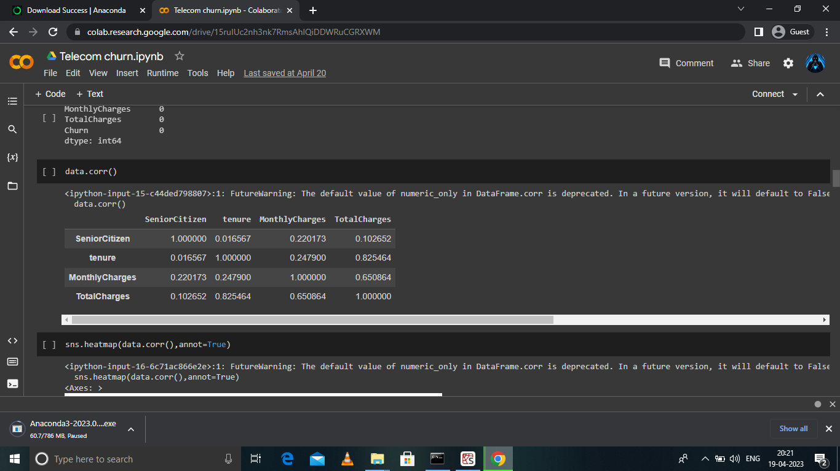

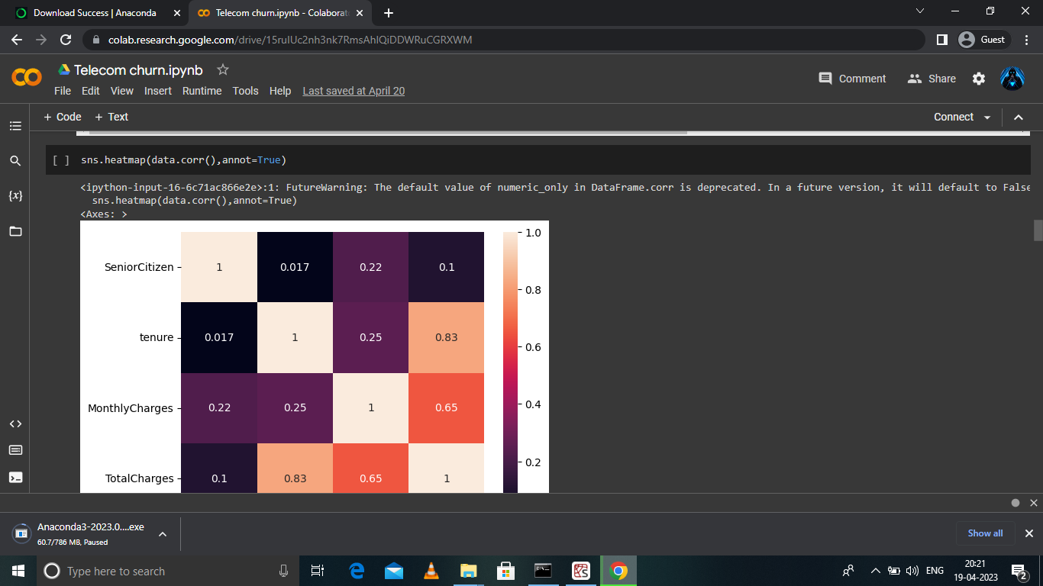

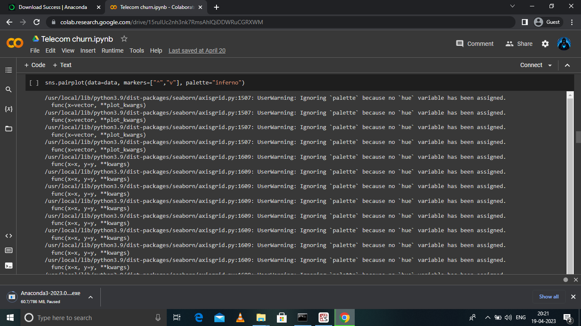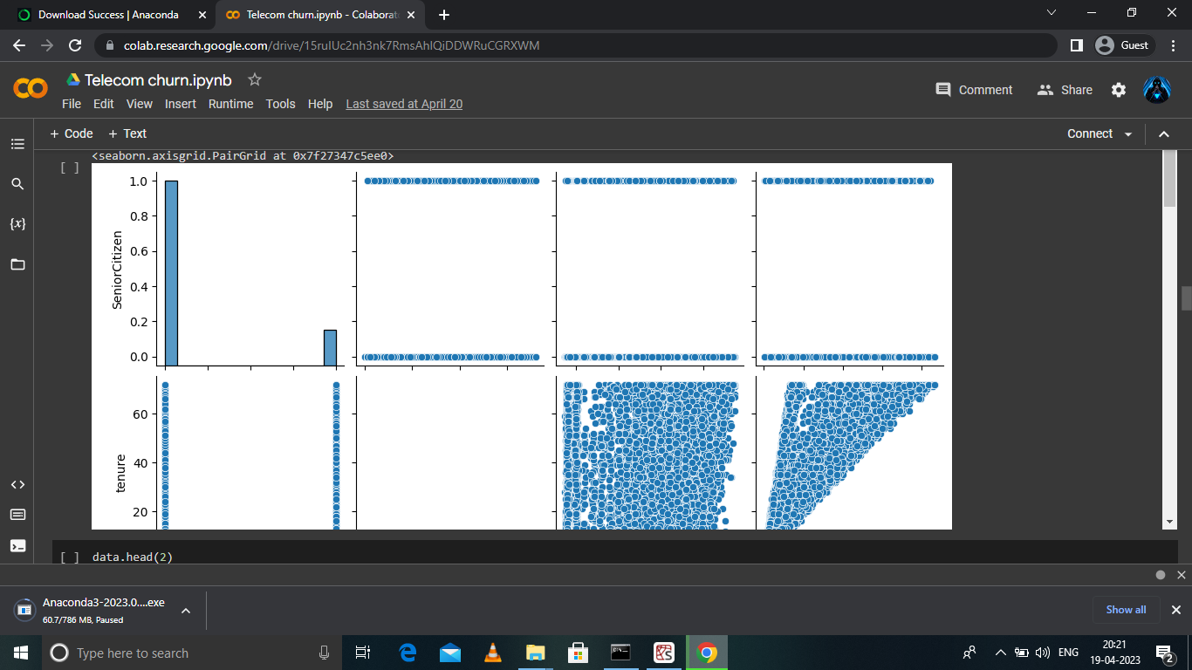

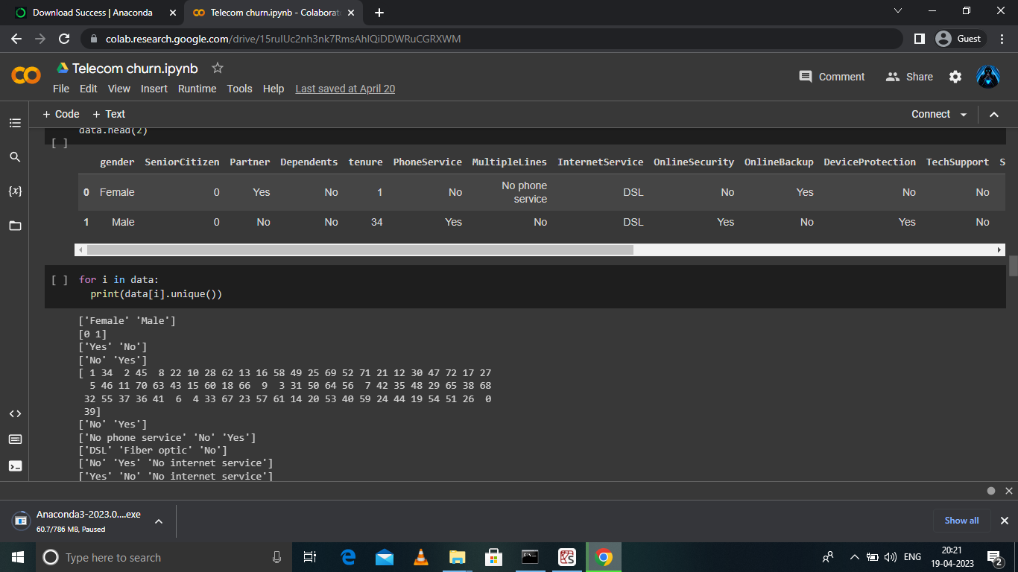

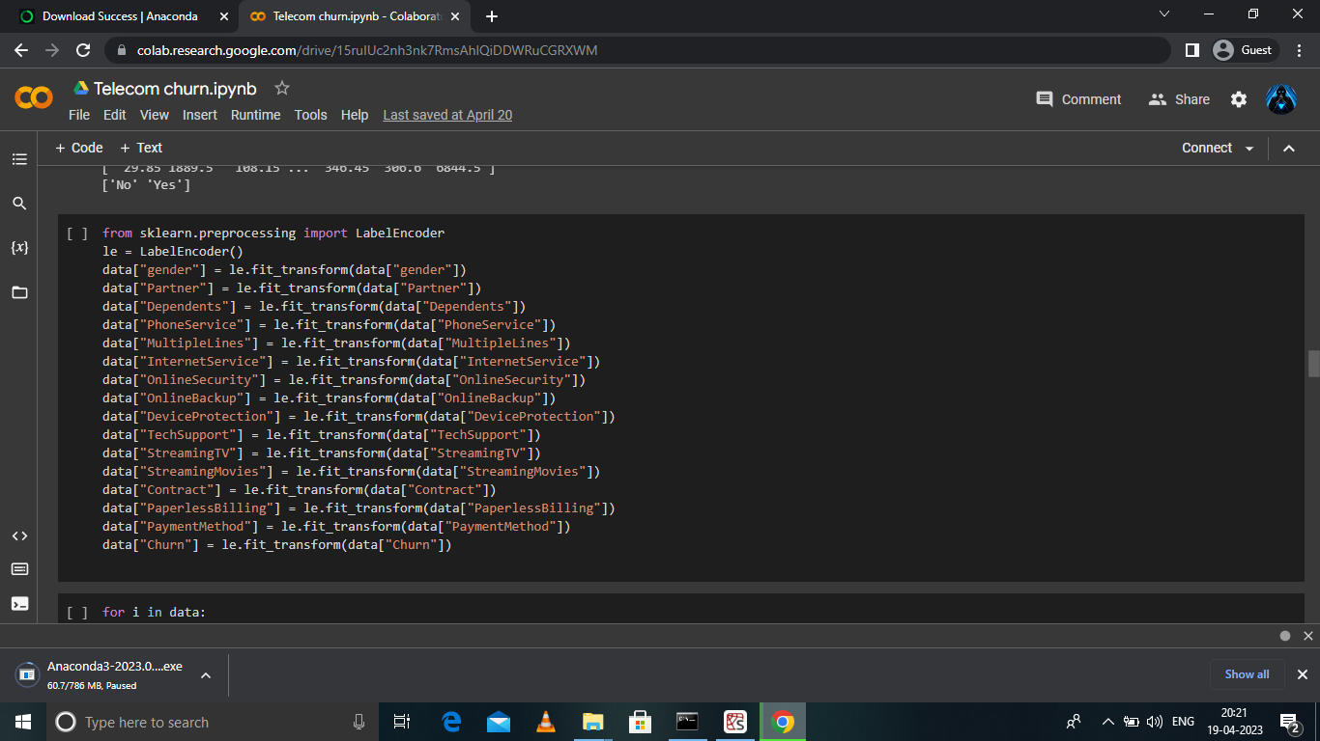



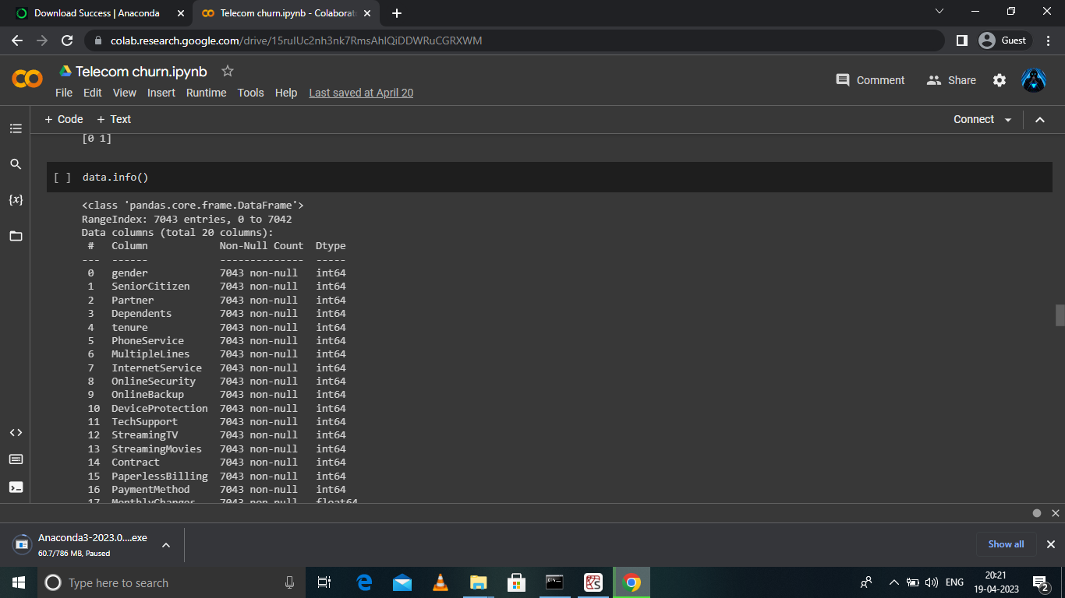

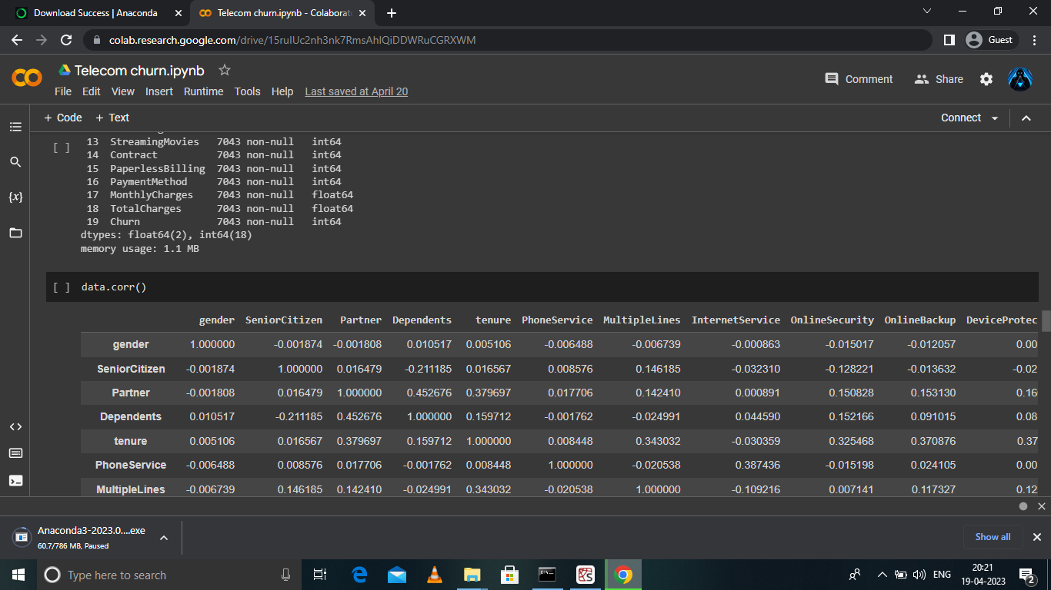



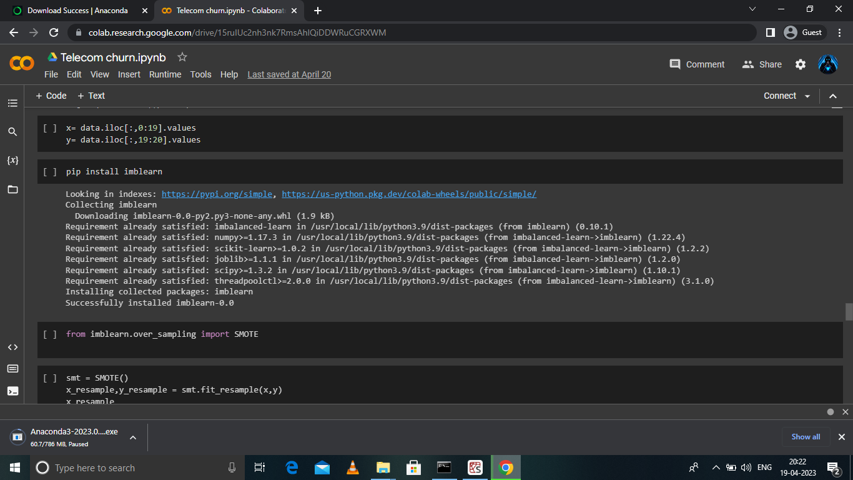

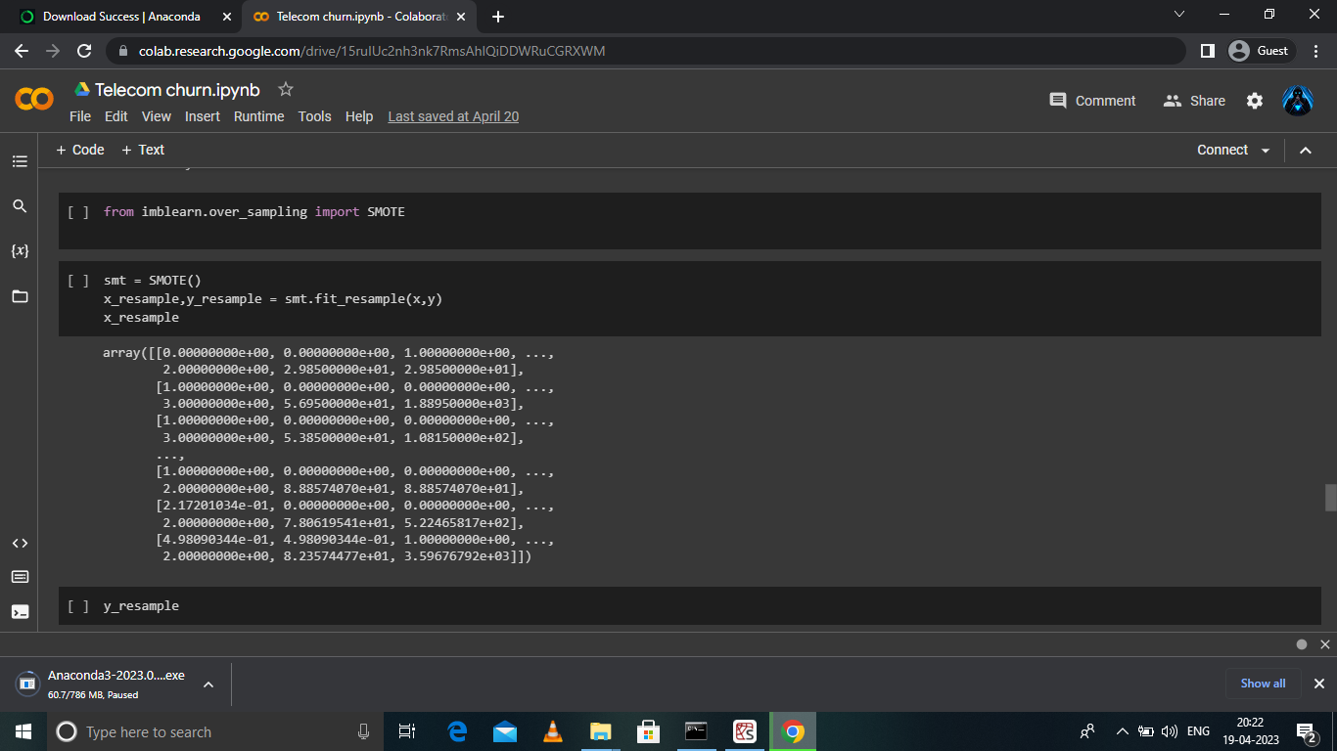

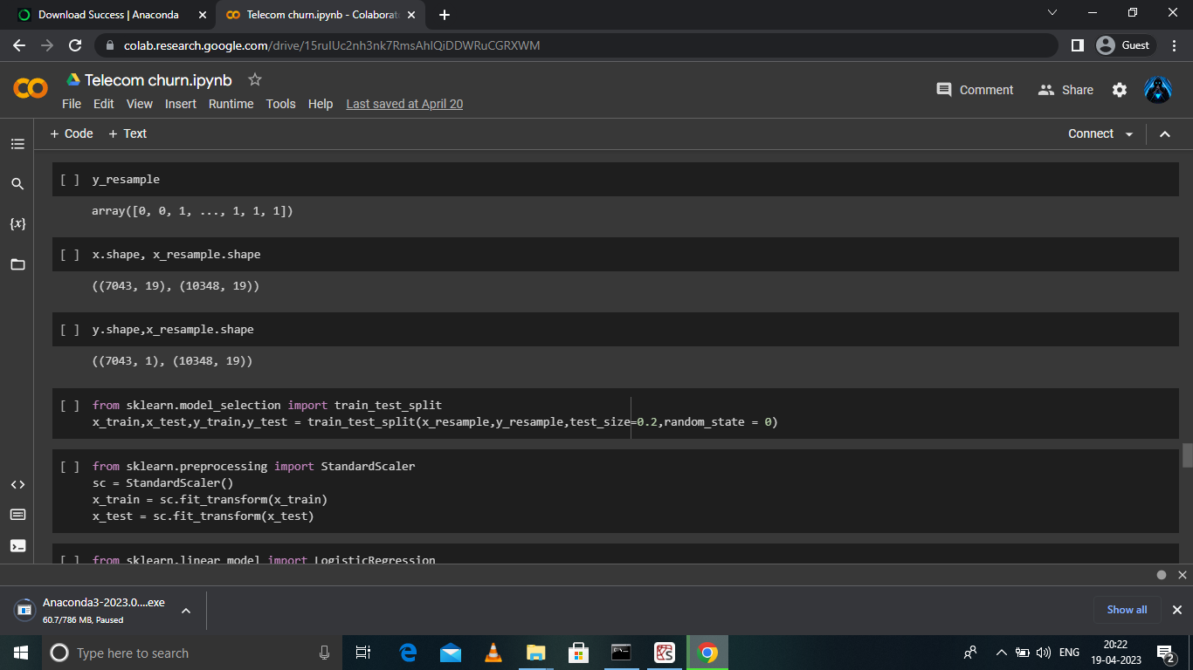

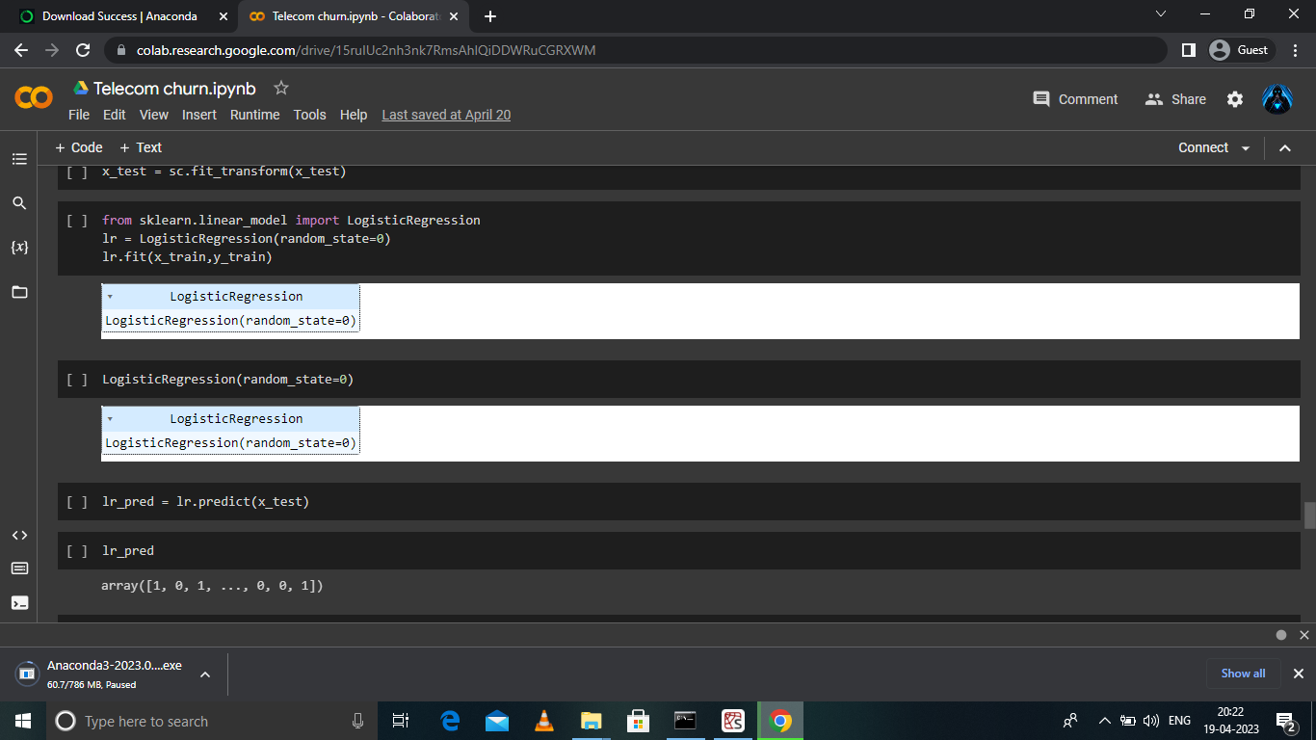

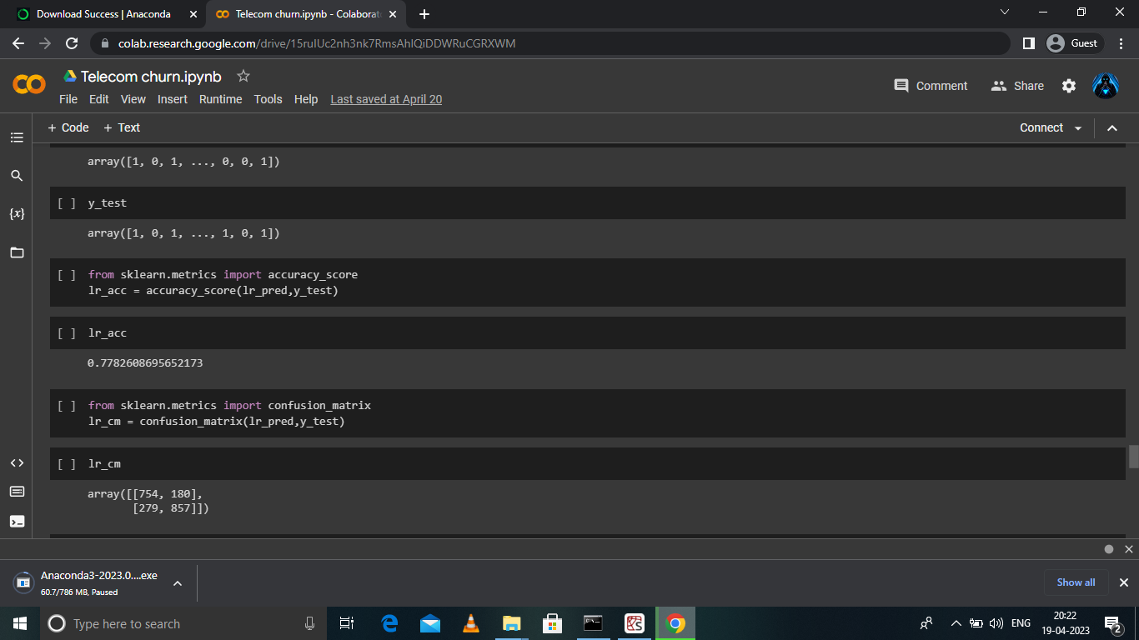

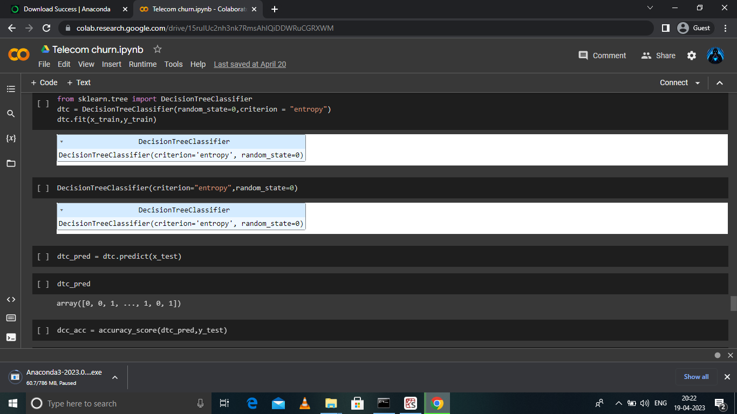

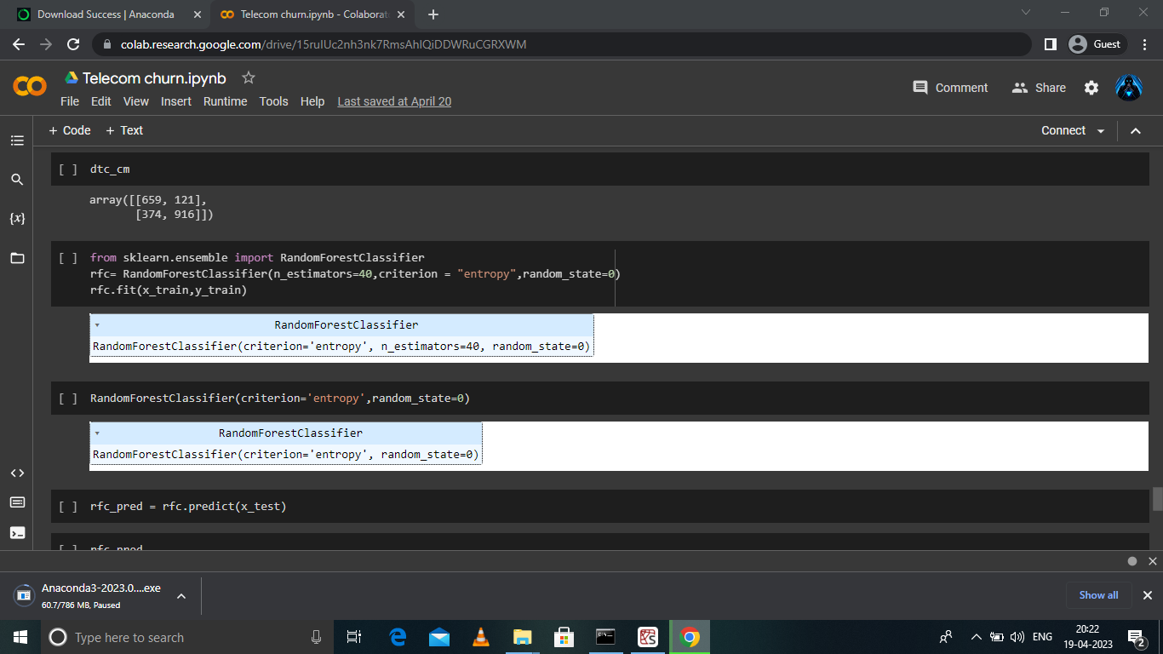

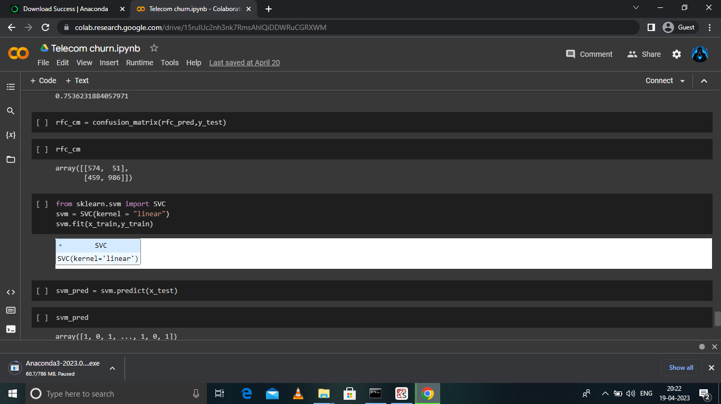

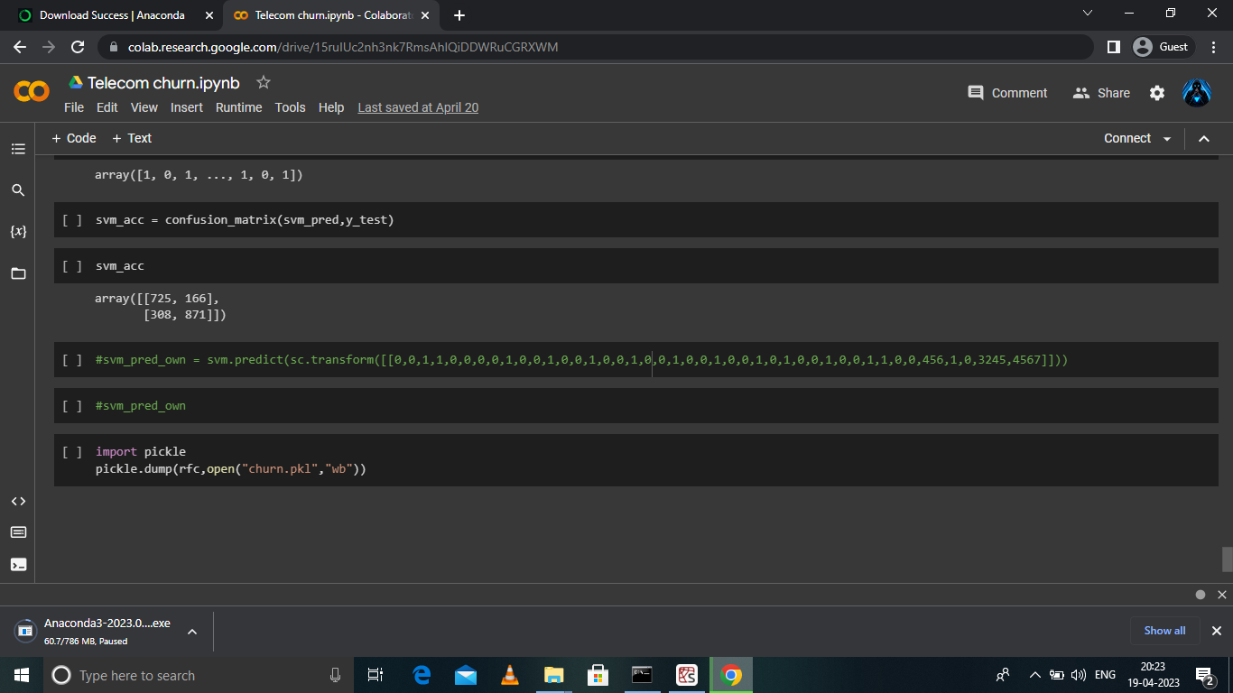**ADVANTAGE:**

* More predictable and stable revenue streams. Shifting from a pay-once model to subscription-based billing allows for better insight into your revenue forecast.
* Optimize the customer experience.
* Better product-market fit.

**DISADVANTAGE:**

* It is vulnerable to overfitting. Also, can't solve the non-linear problem with the logistic regression that is why it requires a transformation of non-linear features.
* Logistic regression will not perform well with independent variables that are not correlated to the target variable and are very similar or correlated to each other.

**FUTURE SCOPE:**

* Our study investigates how machine learning can be used to predict customer churning in the B2B context.
* As mentioned above, churn prediction is one of two parts in customer churn management, and for future work, it would be interesting to investigate what features to use and how they impact churn prediction in the context of B2B.
* It would also be interesting to investigate, based on the variables, what measures could be taken related to retention strategies and how organizations should actively act towards customers that are predicted to churn Another aspect, which would be interesting to further investigate

**RESULT:**

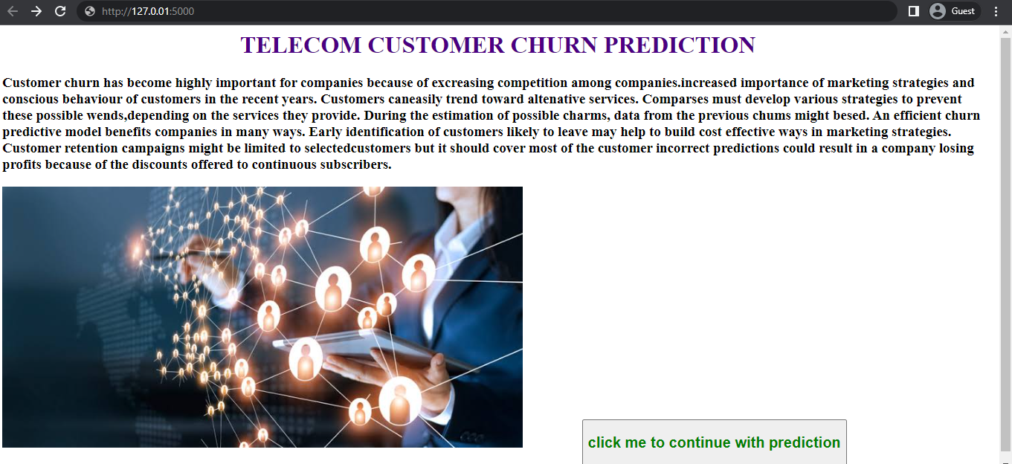

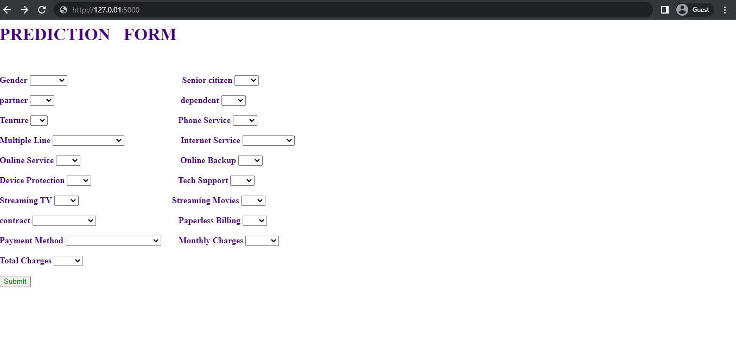

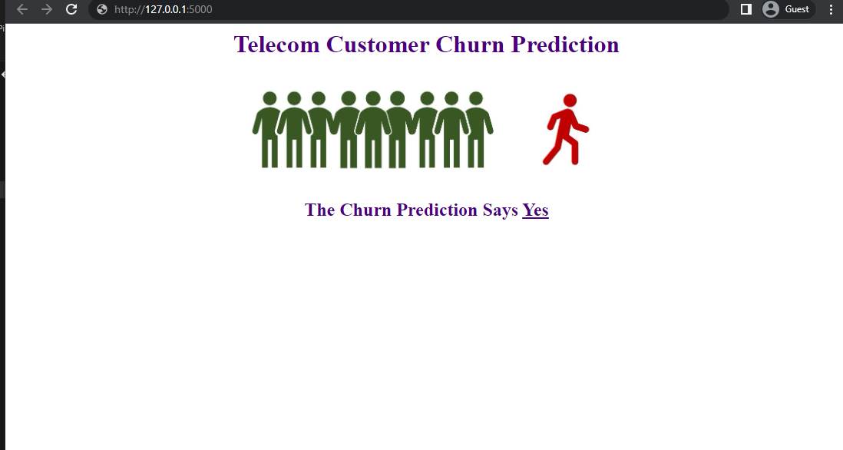

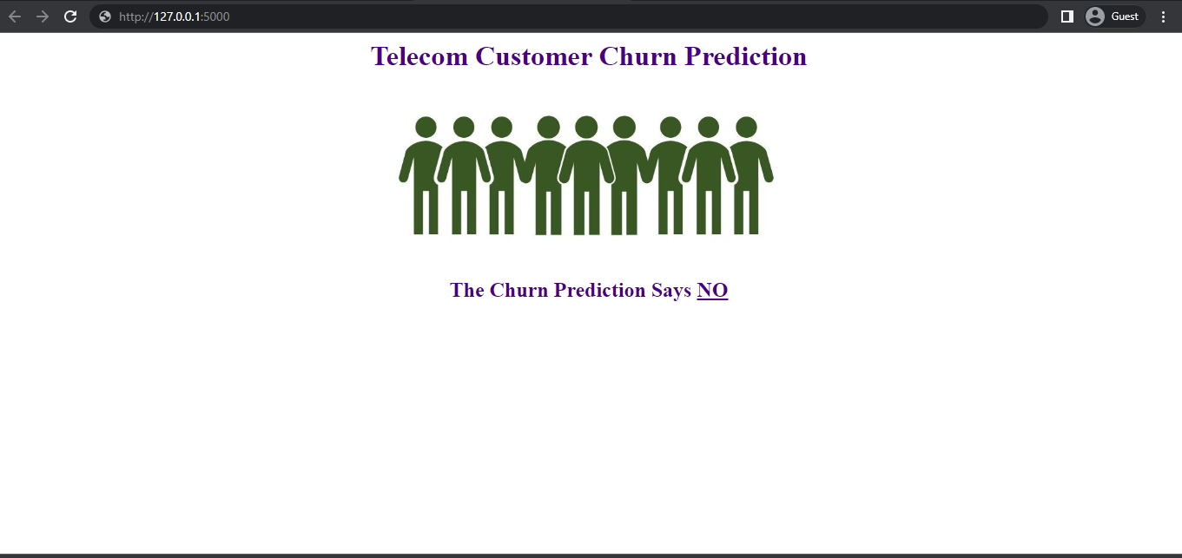

THANK YOU